A. DESPATCH & UNLOADING

1. Loading, for dispatch, will be our responsibility. On receipt of the Dock-leveler at site, please check and ensure that there is no physical damage to the equipment.

2. While unloading the equipment from the transporting vehicle, please ensure to use slings with rated capacity higher than the gross weight of the Stationary lift in packed condition.

3. Slings MUST be hooked ONLY at specified positions. These positions are indicated and marked with a figure of ‘HOOK’. Improper sling position or improper slinging could cause damage to the equipment.

B. ORDERING OF SPARES

1. When ordering for spare, please specify the following in your Purchase Order.

- Equipment Name
- Model Number
- Equipment Serial No.
- Part name / Description
- Part Number
- Quantity required
- Delivery period / time
- Mode of dispatch

This would avoid ambiguity and help us serve you better.

DATASHEET FOR DOCK LEVELER

CLIENT:
- Construction details

1.1 Required Capacity - each : 6 ton
1.2 Model No. : TEDL-2000
  - Leveler operation mode : AC power pack hydraulically operated
  - Lip operation mode : hydraulic
  - Operation control : by push buttons and control panel
  - Loading platform height from road
Level : 1200 mm (Will be confirmed during
Detailing)
1.7 Travel above & below dock level : (+) 350 / (-) 250 mm
1.8 Platform Size (L x W) : 2940 x 2070 mm
1.9 Lip size (L x W) : 2070 x 400 mm
1.10 Maximum slope can be achieved : 8 to 10%
1.13 Clear Pit dimensions (L x W x D) : 2990x 2120 x 485 mm
1.14 Hydraulic power pack
1.14.1 Make “NIHVA”
1.14.2 Driver type : Direct by electric Motor
1.14.3 Absorbed power : 0.75 kW
1.14.4 Motor Ratings : 0.75/1 kW /HP
1.14.5 Degree of protection for motor: IP 55
1.14.6 Class of Insulation for motor : Class F with temp. Rise limited to
Class B
1.14.7 Motor RPM : 1410
1.14.8 Pump design flow : 1.8 LPM
1.14.9 Pump pressure : 200 (max) Kg/cm²g
1.14.10 Safety valve set pressure : 90 Kg/cm²g
1.14.11 in built safety valve : Yes
1.14.12 Pump type : Gear
1.14.13 Valves required : By vendor
1.14.14 Volume of oil receiver : 5 Lit
1.14.15 Dimensions of power pack
Unit : 400 H x 560 L x 340 W mm
1.14.16 First fill of oil / Qty : By Vendor
1.14.17 Hydraulic tubing : By Vendor
1.14.18 Instrumentation : By vendor
1.14.19 Control panel : By vendor
1.15 Empty weight : 1100 Kg

INTRODUCTION: -

The hydraulic Dock Leveler is the result of many years’ experience in materials handling engineering. “NIHVA” offers the best possible factor of safety with simple, easy to use controls. The high quality of manufacture gives a robust construction and many years of useful life. Each lip and platform movement can be individually controlled (or corrected) by push button.

The dock leveler can be set at any position. During loading, the Dock Leveler is in floating mode i.e. it follows the up/down movements of the vehicle deck. Even with lopsided vehicles, the Dock leveler lip will remain in contact, and toe-traps are avoided by the tilt built into the Dock Leveler.

The whole platform is designed to flex laterally adequately to adapt to sideways tilted vehicles. The leveler always seals perfectly to the lorry bed.

PRINCIPLE: -

Dock Leveler is an adjustable platform used between the transport vehicle and dispatch area of the warehouse of factory for efficient and safe material transfer applications. It bridges the gap between the dispatch area and the transport vehicle and compensates for variations in the truck bed height.

CONSTRUCTION: -

It basically consists of heavy duty fabricated Top Cheq. platform and bottom angle channel construction frame. Both are joined by stainless steel machined pins. Lip is hinged to the top platform by means of stainless-steel pins.

Top Platform is reinforced with I Beam welded below the platform to strengthen the platform. The cylinder is mounted at the best advantage point against the top platform and bottom frame. Compact power pack includes a single HP motor with overload protection. Hydraulic Pump is Dowty make. Hydraulic operations are by using solenoid control valve.

FEATURES: -

- Convenient location of all controls.
- Independent deck and lip.
- Controls for quicker cycling time.
- Smooth dependable hydraulics.
- Quite operation at the touch of the button.
- Years of trouble-free service.
- Lower lift time cost and fewer maintenance requirements.
- Recommended for all applications.
- Maintenance Strut.
- Hazard Stripes.
- Toe guards.

PRE – OPERATING INSTRUCTIONS:-

- Ensure Hydraulic Oil in the power pack.
- Ensure Motor connection and proper earthing.
- Ensure joint leakage.
- Ensure proper location of platform and lip.

ROUTINE MAINTENANCE AND LUBRICATION

These recommendations are applicable to the Dock Leveler considering average daily usage of 15 to 20 times. If it is used more frequently, the same time intervals for the maintenance should be adjusted accordingly.

DAILY: -

- Check Hydraulic pipe lines for leak proof working.
- Check electrical connections for their proper working.

MONTHLY: -

- Grease the hinge pins at bottom frame and top plate joint and extension lip plate hinge joint.

- Grease the main Jack Cylinder and Lip Jack Cylinder, Front and Rear Trunion bearings.

- Change Hydraulic Oil.

ASSEMBLIES
&
SPARE PARTS LIST

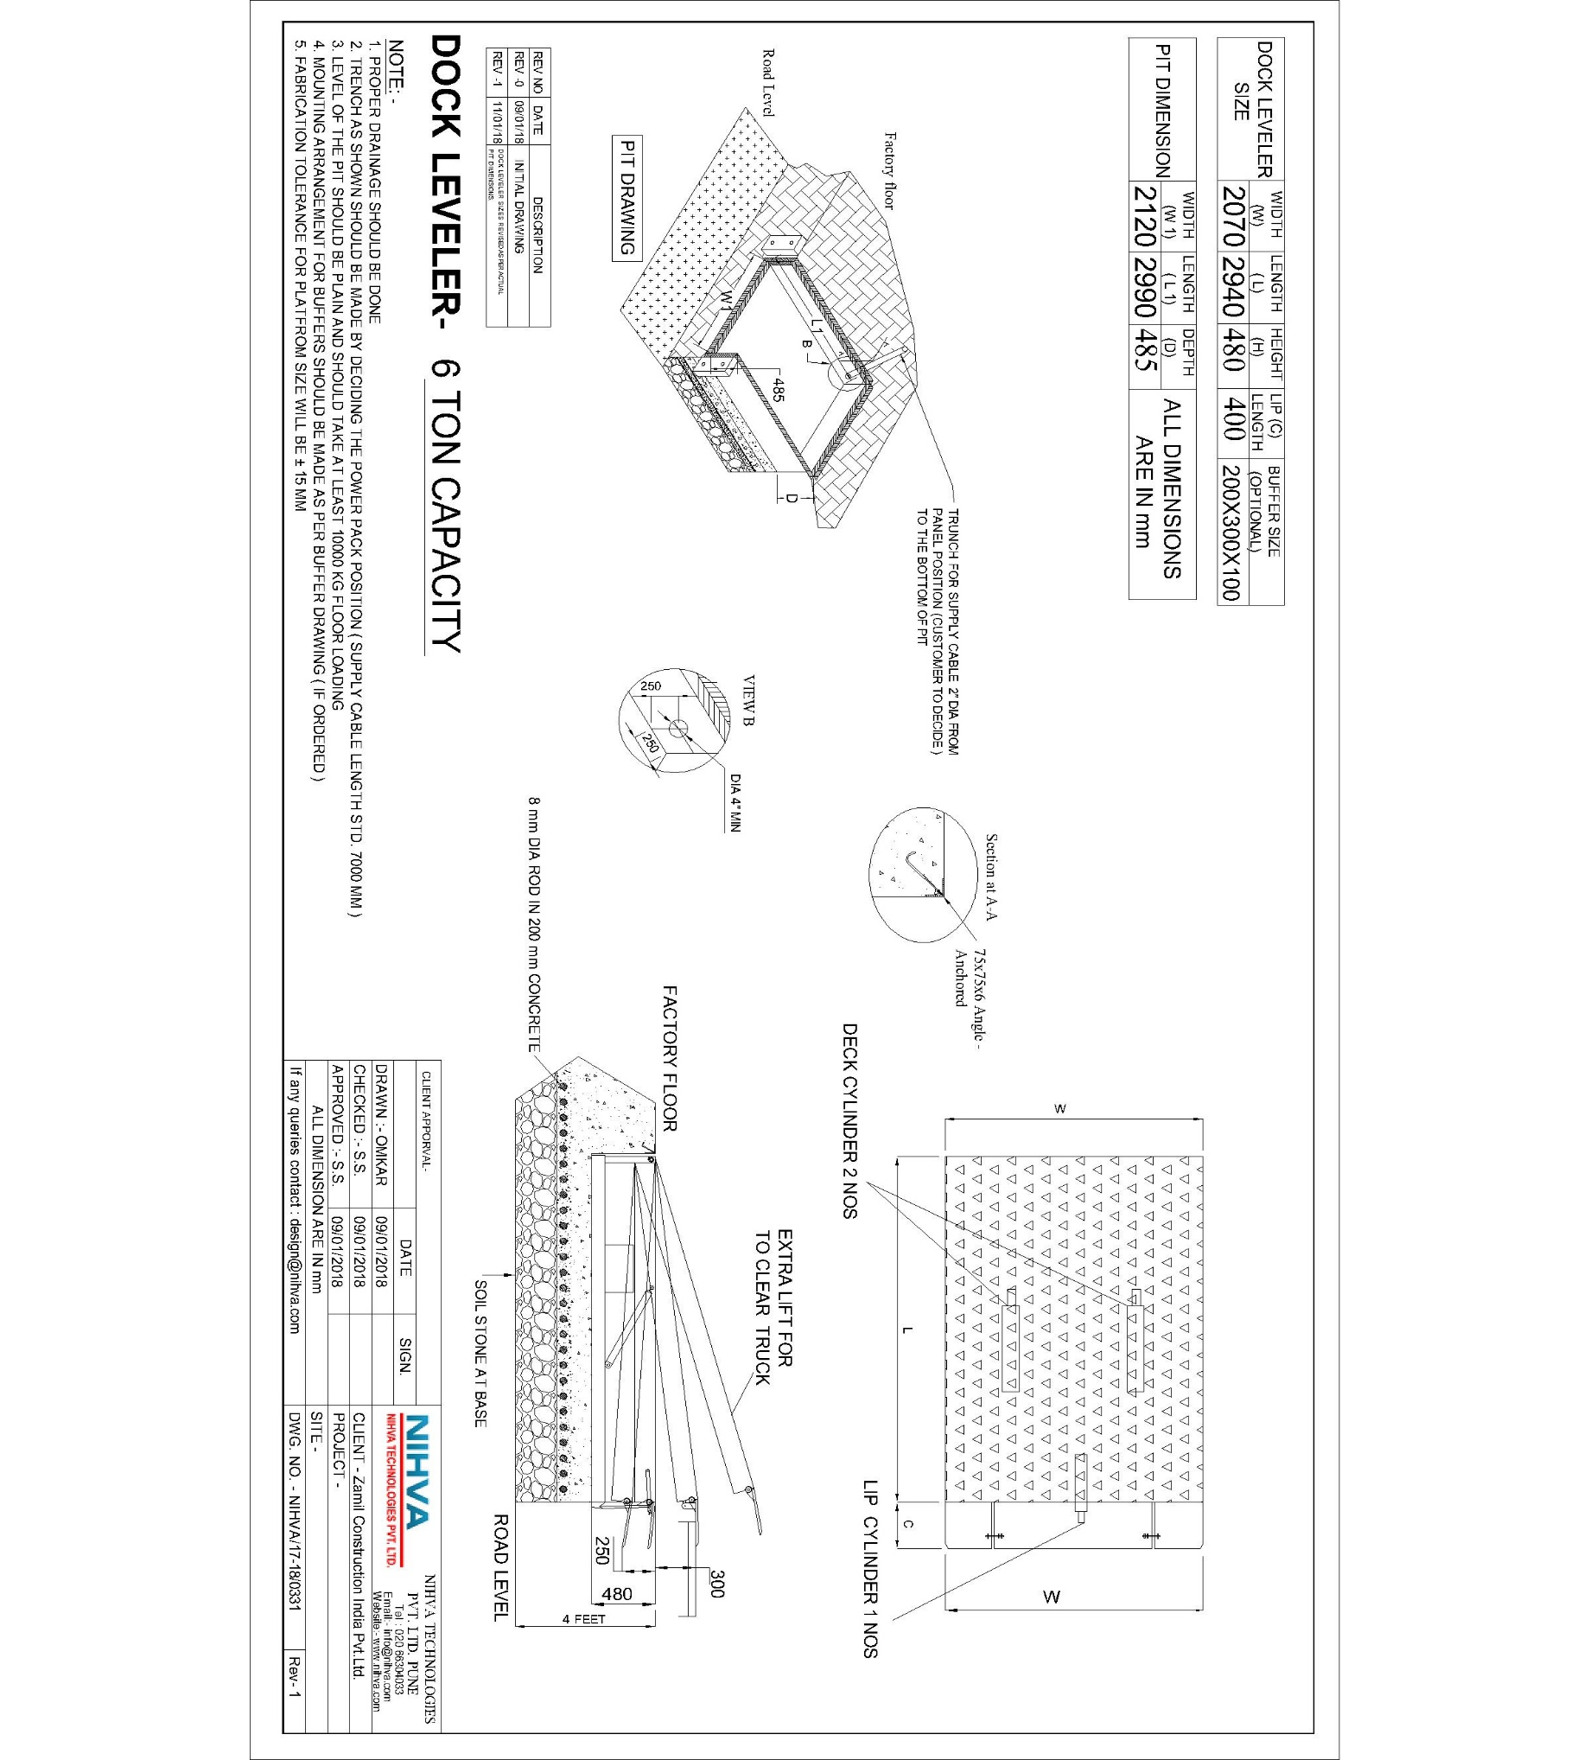

NEW MODIFY DOCK LEVELER ELECTRIC CIRCUIT:-



